**EXPERIMENT -1: Docker Insatallation**

**For Windows**

**Step-1:** Go to the browser and search docker desktop. Download docker desktop.

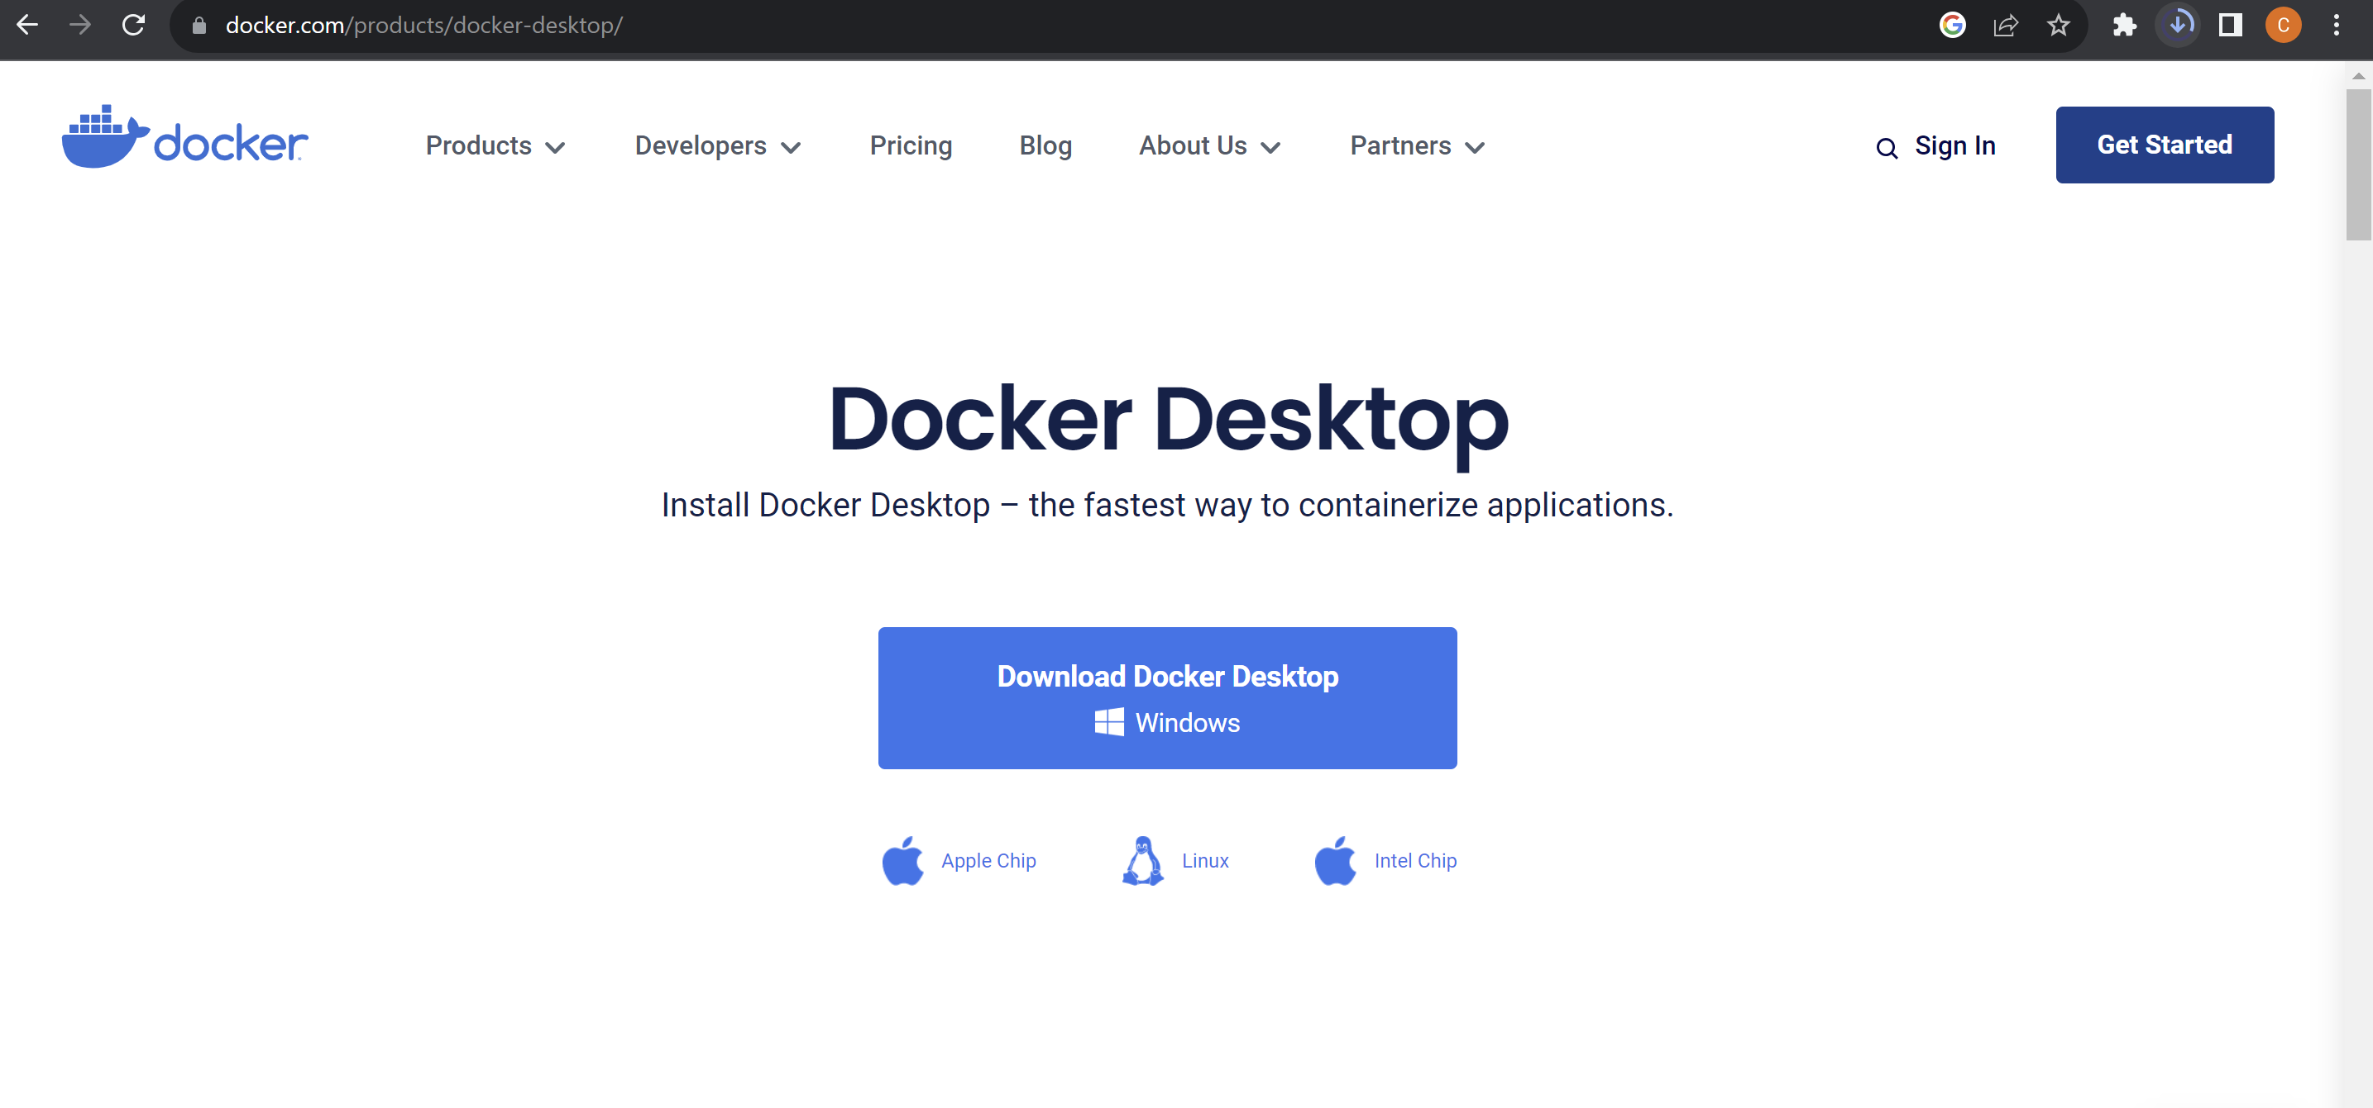

**Step-2:** Run the downloaded .exe file and complete the docker installation.

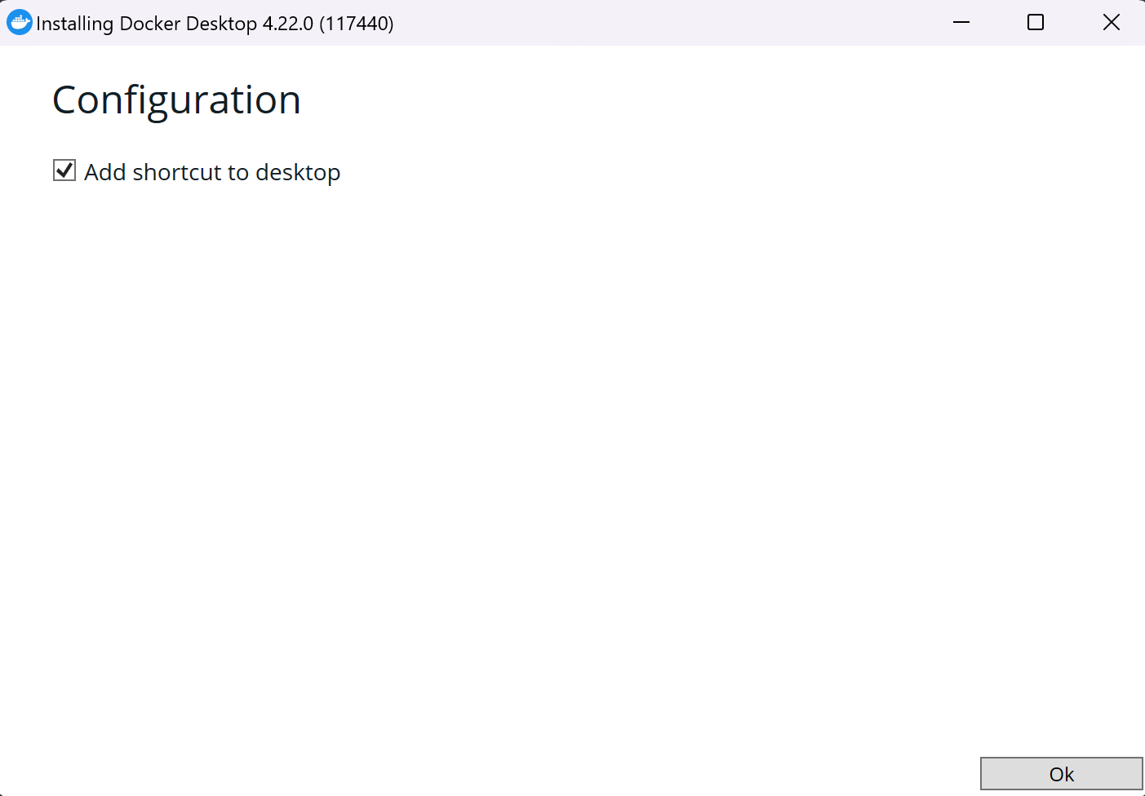

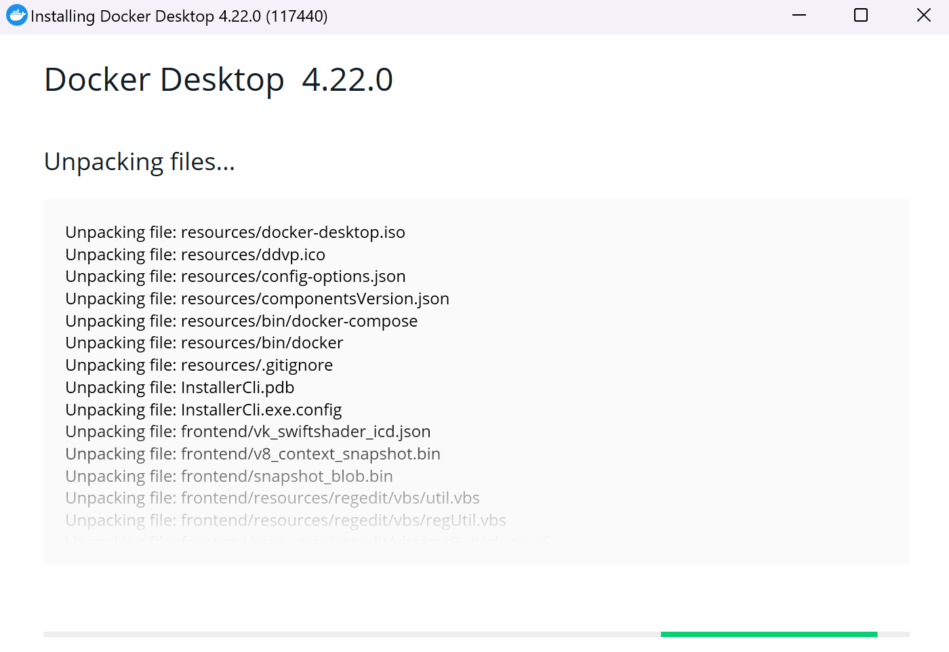

**Step-3:** After the installation is complete, go to command prompt and write the command – “ docker –version”.

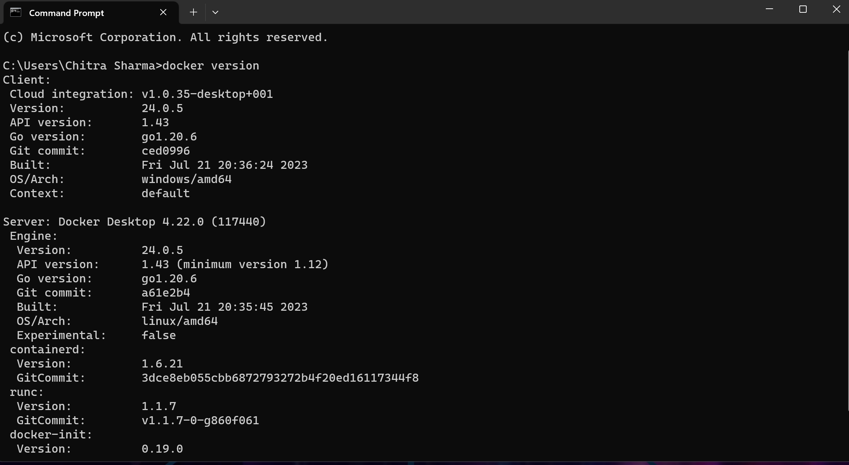

**Result:** Client and Server information is displayed hence the docker is installed and running.

**For Ubuntu**

**Step-1:** Go to the native ubuntu application and update the ubuntu using the command – “sudo apt update”

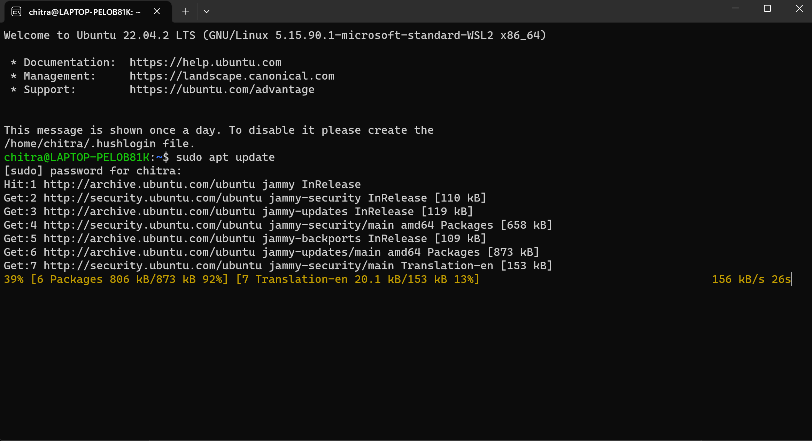

**Step-2:** After the successful updation, upgrade the ubuntu using the command – “sudo apt upgrade”

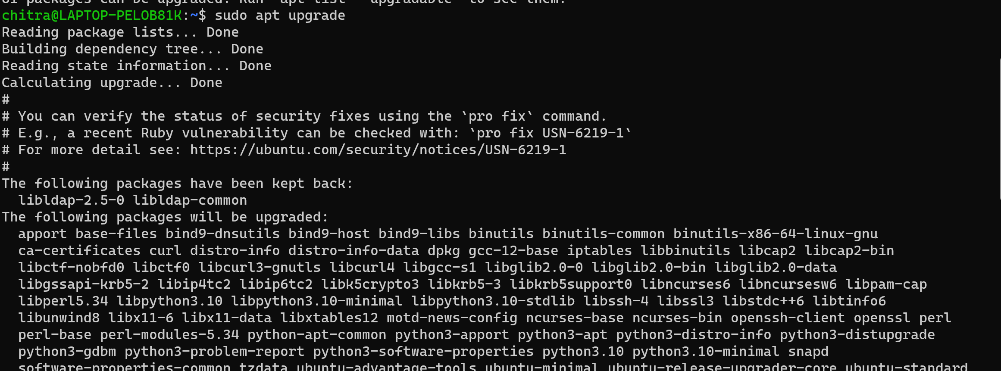

**Step-3:** After updating and upgrading the ubuntu, install docker using the command – “sudo apt install -y docker.io”

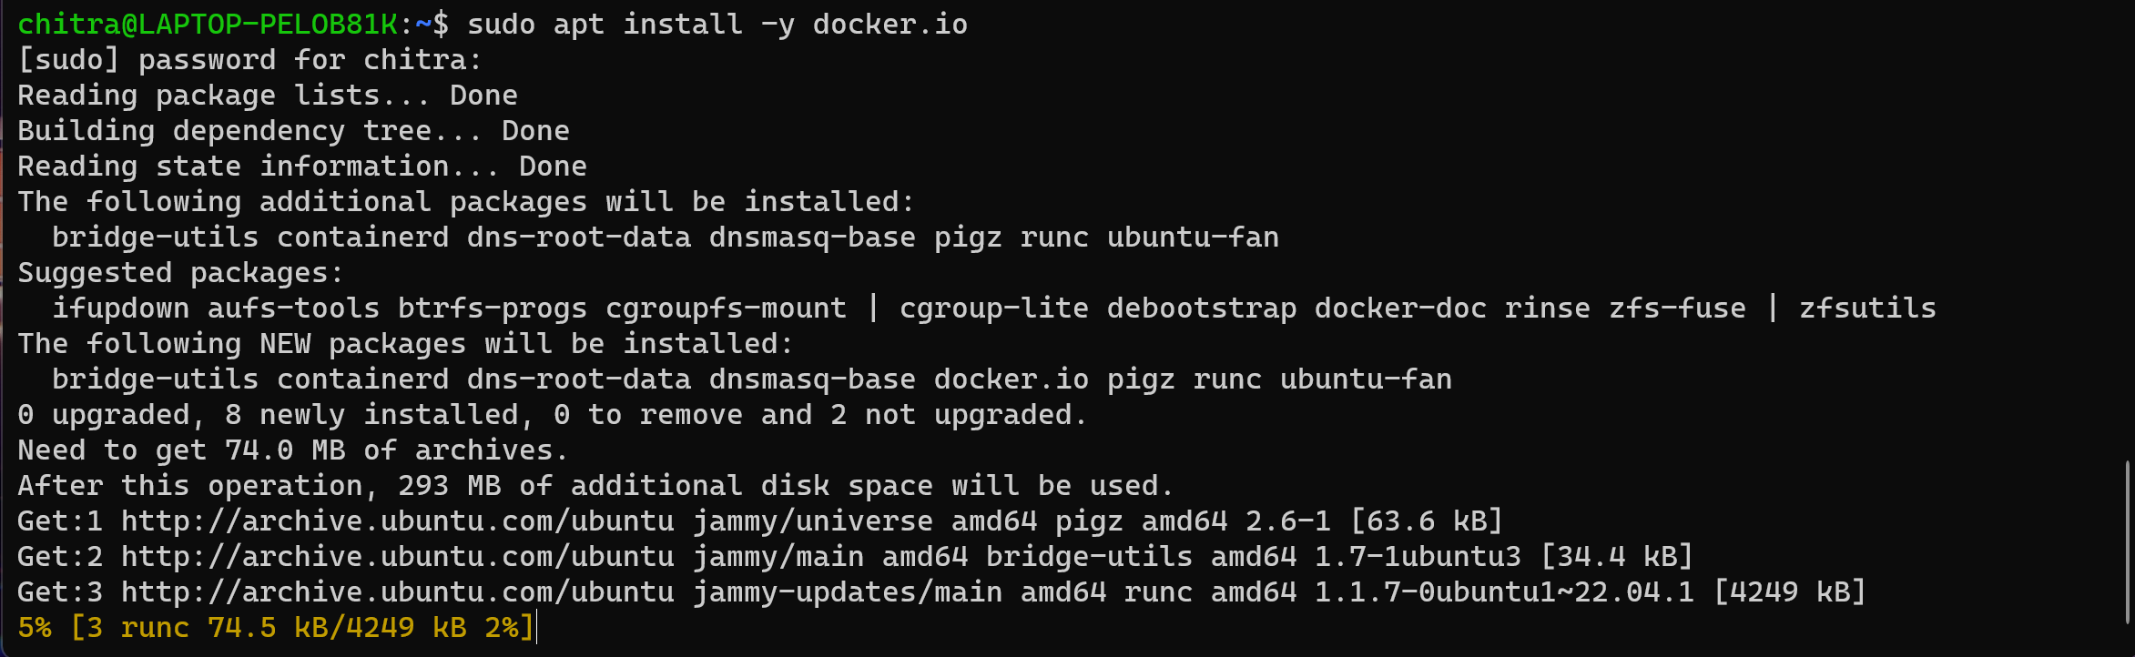

**Step-4:** By running the “docker info” command, check whether your docker is successfully installed or not

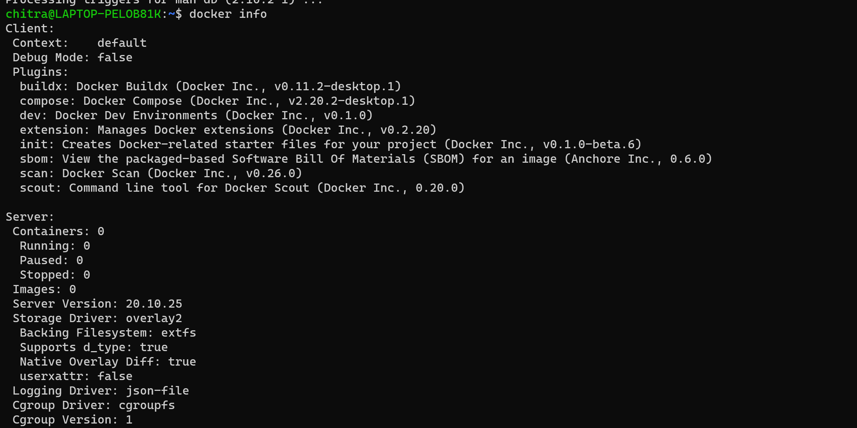

**Result:** Client and the server details are displayed hence the docker is successfully installed on Ubuntu